SwamiG Institute
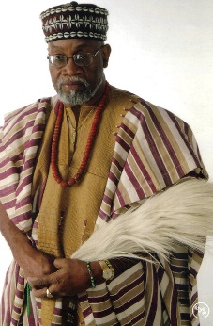

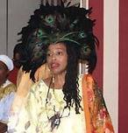
“Extending Royal Legacy”
HRM Nwa Chukwu Eri NashidKoleosoKarade
HRM Queen Mother OsunnikeIfeyinwaAnke Eri
Anke-Karade Lineage Founders

AwiseWande Abimbola &Iya Besie Abimbola –  Nigeria West Africa | 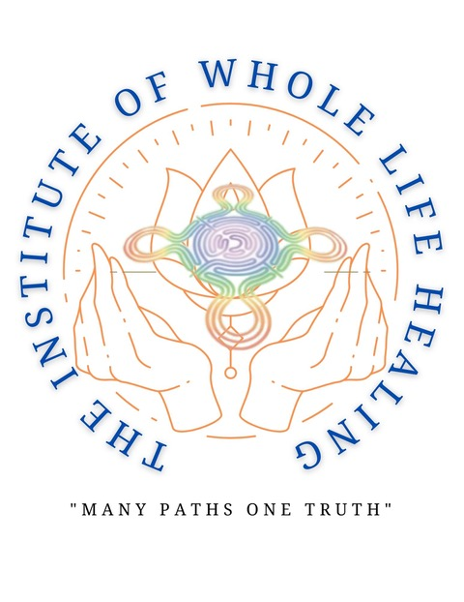  1-Know Thyself( Heru) Ilekes  2-Cleanse and Purify (Herukhuti) Warriors  3- Living in Alignment With Absolute Truth( Ausar) Hand Of Ifa | YaagbeOrisaKeyeAgbede – Nigeria West Africa
Iya Omoladun Anke – Nigeria West Africa |  | Chief Araba Malomo – Nigeria West Africa
Baba OgunyeyeAkangbe – Nigeria, West Africa |  | Baba Oloye Ifa Karade – US
IyaOsunnikeAnke – US |  | Baba Koleoso Karade – US
HRM Queen Mother Osunnike Ifeyinwa Anke Eri |  | HRMNwa Chukwu Eri NashidKoleosoKarade
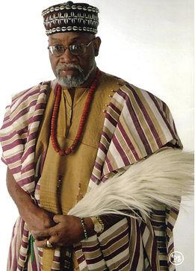
PriestKing Nwachukwu EriNashidKoleosoKarade

Extending Royal Legacy

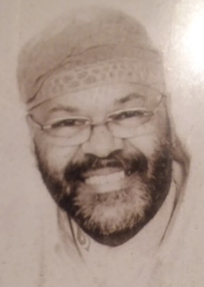

AwoFasuuruateAnke-Karade- US
“SwamiG”

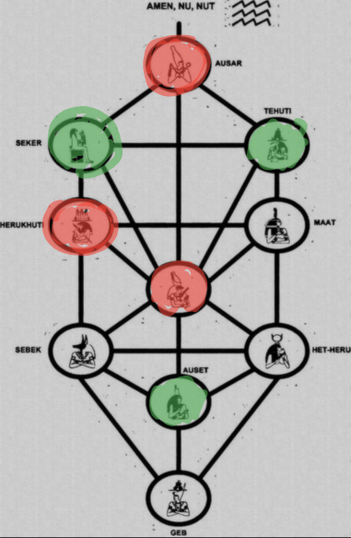


SwamiG Institute and its three(3) pillars: wisdom, words and devotion,
2
- Infinite Wisdom(Tehuti) Ilekes
- Speaking words of power (Sekert) Warriors
- Transformational Devotion(Auset) Hand of Ifa

“…Extending Royal Legacy…”
“…on the shoulders of enlightened ancestors…”

